Beckley’s Kids Classic Festival 2019 Schedule / Passport
Get your passport stamped at locations indicated by this symbol:
At least 3 stamps required to be eligible for grand prizes.

Saturday, August 31: Boots vs Badges Charity Softball Game, 2 pm, Epling Stadium, Adults $5, Children $3; 5 and under free
Monday, Sept. 2: New River Park Pool – Last day to enjoy the pool this season – children can receive a $1 off discount – show this passport.
Monday, Sept. 2: McManus Trail event – Kids Car & Bike Show 5:00-6:30 pm (bring your battery-operated or pedal car, bicycle, tricycle, wagon, scooter, or decorated stroller to display at the trail shelter near Prince Street McDonalds) – register 5:00-5:30, 6:00 pm short cruise on the trail, and awards presented. Also, enjoy McDonalds Monday McFamily Night 5-7 pm, a bike safety rodeo, and/or a walk to the mural wall.

Tuesday-Saturday, Sept. 3-7: Leisure Lanes - One free game of bowling & shoe rental per child when accompanied by a paying adult, 10am – 9pm, call for lane availability 304-253-7328
The Pottery Place – receive a free tile with any purchase – please show this passport.

Tuesday, Sept. 3 – Humane Society’s Puppy Swim Pool Party at New River Park pool, 5-7pm

Wednesday, Sept. 4 – Active SWV and National Park Service Group Bike Ride, McManus Trail, 6pm, 3rd Ave lot. If you don’t have a bike, call 304-894-2129 or email getactiveinthepark@gmail.com to reserve one.

Thursday, Sept. 5: Crescendo House – Children & parents can enjoy Instrument Exploration in the Kindermusik room, 4-6 pm, Ragland Road

Thursday, Sept. 5: Raleigh County Library Meet & Greet - children’s author Elaina Rae & the reading of her book “Stay Awake, Moon,” 5-7 pm, plus art session with illustrator

Friday, Sept. 6: Baby Fair, 11 am–1 pm, Word Park, Neville Street; Classic Pretty Baby Contest – Entry $10 + diapers for baby pantry, Ages birth to 4 years (pre-register by Sept. 1 - call 304-252-4769)
Friday, Sept. 6: Youth Museum & Exhibition Mine (6-8 pm), See FunnyBones Balloon & Magic Show at the amphitheater, 6-7 pm; Inside the Youth Museum: Storyland Exhibit & Planetarium Shows; Exhibition Mine - Underground mine tours; Admission inside Youth Museum & mine tour = $5

Saturday, Sept. 7: Kids Street Fair-10 am–2 pm; Main & Fayette Streets
Festival Booth (Main Street) – festival shirts, passports stamped
Stroll along streets to check out various booths, games, food vendors …
Beckley Fire Dept.’s Junior Firefighters Challenge
United Bank Games Arcade (game card = $6 or ½ game card = $3; ticket booth closes at 2 pm) - Prize Wheel, Dunk Booth, Money Machine, Bounce House, Poppy Troll KidQuest character & more games
Federal plaza by Heber Street: Sci-fi and Fantasy area; Wizards Unite; Bicycle Raffle for Ronald McDonalds House
Parade at 11 am - Children’s characters, queens, bands, teams … Theme: What’s Your Story? One Community … Many Stories!
After parade: Band drum lines; cheer & dance teams; Youth performers; Bookmobile, meet/photos with characters …
Saturday evening activities: 7:30 pm – Home Run Derby at Beckley Little League – ages 8 & up, $5 derby entry fee, win cash & prizes;
9 pm – Fireworks

Sunday, Sept. 8: Youth Museum: Hamster Races (free) 1 pm, plus Dazzling Dog Show ($5 pet registration) 2:15 pm – must be on a leash or in a cage (Info: 304-252-4769)

Prize Registration: Child’s Name: _______________________________
Age: ____ Circle: Male or Female School: ______________________
City, State, Zip: _________________________ Phone #: _______________ Parent’s name: __________________________________
Turn-in your passport / drawing registration at hamster races on Sept. 8 or at the Street Fair booth on Sept. 7. Grand Prize Drawings on Sept. 9 at 2pm
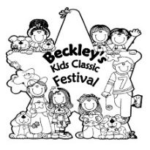 Thanks to our generous
Kids Classic Festival Sponsors:
United Bank
Raleigh County Commission
Jan Care Ambulance
Mac’s
Best Ambulance
SMART529 / Hartford Funds
Quick Prince Printing
McDonalds
Ward Law Office
103CIR and 93.5 The Buzz
The Register-Herald
99.5 WJLS
Beckley Events / City of Beckley
WV Fairs & Festivals Grant / Irish Heritage Grant
Special Thanks to our Event Hosts:
McDonalds/The Pottery Place, Leisure Lanes, Raleigh County Library, Youth Museum/Exhibition Mine/Parks & Recreation, Classic Pageants, United Bank arcade sponsors, Beckley Little League, Crescendo House
Info: Beckley Events Committee – Info: 304-256-1776,
www.beckley.org “Beckley Events” on Facebook

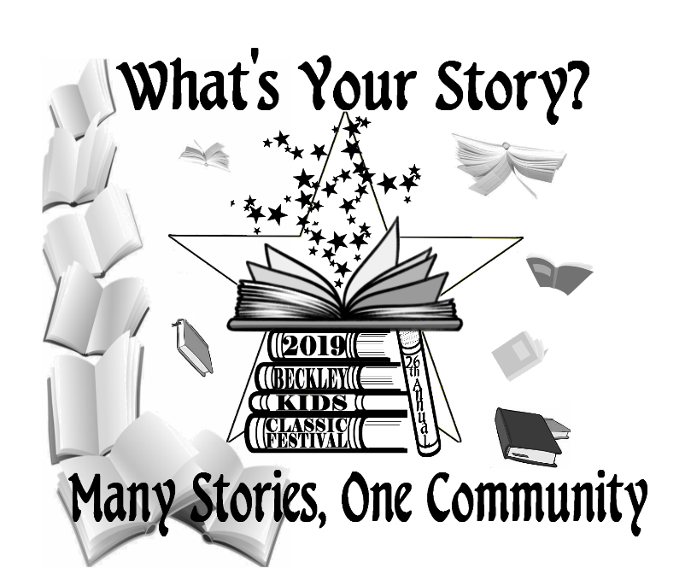

Beckley’s 26th Annual
Kids Classic Festival

August 31 – September 8, 2019

2019 Festival Theme:
“What’s Your Story?
Many Stories, One Community”

See 2019 Schedule / Passport on the other side

